LAB 06

Name: Muhammad Mohsin Nawaz

Class: BSAI-3B

Roll Number: SU92-BSAIM-F25-102

Submitted to: Sir Rasikh Ali

1. Scenario and Objectives

1.1 Scenario
This lab simulates a university IT and administration help desk. A student types a question in everyday language, such as “I was sick; can I hand work in tomorrow?”, and the system has to locate the passage in the handbook that answers it. The handbook is made up of five synthetic documents that I worked with throughout the lab. Each is roughly 150 to 250 words long.

1.2 Objectives
- Compare three ways of splitting text into tokens: whitespace splitting, a Unicode word-like regular expression, and the subword tokenizer of all-MiniLM-L6-v2.
- Embed text with a sentence-transformer model and measure model-load, encoding and search time separately.
- Build three chunking strategies and compare their chunk statistics and how well they keep a rule together with its exception.
- Compare TF-IDF retrieval with embedding retrieval using Hit@3 and MRR@3, tuning on four development queries and then checking four held-out test queries.
- Wrap the chosen configuration in terminal chatbots that show evidence, ask the user to confirm a passage, and fall back safely when nothing relevant is found.
- Record limitations and real failure cases, and reflect on what they mean for a production system.

2. Tokenization Comparison
I ran the same six test strings through three tokenizers. The strings were chosen to be awkward on purpose: sentence punctuation, a contraction, an email address, a course code with a version number, an empty string, and a filename containing an underscore, a dot and a hyphen. In the table, n is the number of tokens produced.
Table 2. Tokenizer outputs for the six test inputs
Input | Whitespace | Regex | Model subwords
AI, search! | ['AI,', 'search!'] n=2 | ['AI', 'search'] n=2 | ['ai', ',', 'search', '!']
I can't log in. | ['I', "can't", 'log', 'in.'] n=4 | ['I', 'can', 't', 'log', 'in'] n=5 | ['i', 'can', "'", 't', 'log', 'in', '.']
help@example.com | ['help@example.com'] n=1 | ['help', 'example', 'com'] n=3 | -
CS4944 version 2.1 | ['CS4944', 'version', '2.1'] n=3 | ['CS4944', 'version', '2', '1'] n=4 | -
(empty) | [] n=0 | [] n=0 | -
file_v2.1-final | ['file_v2.1-final'] n=1 | ['file_v2', '1', 'final'] n=3 | -
The Model subwords column is filled in only for the first two inputs: the script prints the encoder’s subword tokens when n < 2 (the column header in the output reads “Model subwords (2 EN)”), and the other rows show “-”.
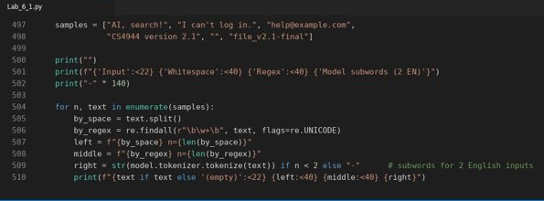
Figure 1. run_task1() in VS Code: the three tokenizers applied to the six test strings.

2.1 What the comparison shows
Whitespace splitting is the most literal. It never changes a character, so the email address, the number 2.1 version and the filename each survive as a single token. The cost is that punctuation stays attached to words: 'search!' and 'in.' are different strings from 'search' and 'in', which would be treated as different vocabulary entries by a keyword index.
The regex tokenizer removes that punctuation and gives clean word tokens for the first input. However, it cuts at every non-word character, so can't becomes can and t (five tokens instead of four), the email turns into three pieces, 2.1 becomes 2 and 1, and the filename becomes file_v2, 1, final. The underscore is kept inside file_v2 because the pattern treats it as a word character. If the original string is thrown away after tokenizing, this splitting loses information, which is a normalization risk.
The model’s subword tokenizer gives a third view. For the two inputs shown, it lowercases the text and keeps every punctuation mark as its own token, so the contraction becomes seven tokens. Every word in these two examples stayed whole; the visible differences from the regex output are lowercasing and the retained punctuation. This tokenization exists to feed the encoder, so I only treat it as part of the embedding path and not as a way to build keyword features.
The practical lesson is that the token boundary decides what a retrieval index can match. A choice that looks harmless on plain words can split identifiers, emails and version numbers, so the tokenizer should be picked to suit the backend that uses it.

3. Embedding Approach and Timing Method

3.1 Embedding model
For dense retrieval I used sentence-transformers/all-MiniLM-L6-v2, running on CPU. Every chunk and every query is turned into a vector, and passages are ranked by cosine similarity to the query vector. The model’s max_seq_length was reported as 256.
TF-IDF stayed in the comparison as the keyword baseline. It is very cheap and works well when the query shares exact words with the handbook. Embeddings were more useful when the student phrased things differently from the document, which Section 5 demonstrates.
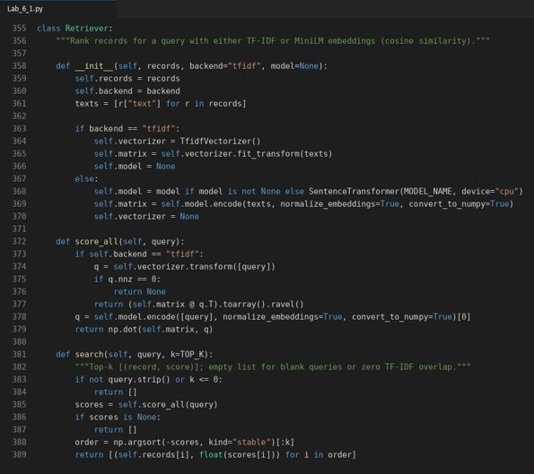
Figure 2. Retriever class in VS Code: TF-IDF and MiniLM backends behind one search() method.

3.2 Timing method
Timing was split into three measurements, so the numbers are not mixed together. The model was loaded one time at start-up and timed once. After that, encoding time and search time were measured separately for each chunking configuration. The model was not reloaded for each strategy, so the encoding figures do not include load cost.
Model load seconds: 2.031
Model max_seq_length: 256

The per-configuration encoding and search times are given with the evaluation results in Table 7.
Before any strategy is evaluated, audit_token_lengths tokenizes every chunk and query without truncation and compares the longest one with the encoder’s max_seq_length of 256. The script stops with an error if anything is longer, so nothing is silently truncated by the model.

4. Text Chunking Strategies
The same five documents were cut up in three different ways. Retrieval then works on chunks rather than whole documents, so where the cuts fall affects what can be found.
Table 3. The three chunking strategies
Strategy | How chunks are formed
0overlap | Consecutive windows of 40 words with no shared words between neighbouring chunks.
10overlap | Windows of 40 words in which neighbouring chunks share 10 words.
sentence | Sentence-aware packing: whole sentences are added to a chunk until the 40-word budget is reached. A sentence longer than 40 words is handled by sentence_chunks falling back to word windows.

The chunking code also validates its settings. windows() raises ValueError unless size > 0 and 0 <= overlap < size, and sentence_chunks() raises it when size is not positive. The script’s built-in chunking tests (run_chunk_tests) all passed: empty text gives no windows, a short document gives one window, overlap equal to or above the window size and negative overlap are both rejected, a 95-word sentence is cut into spans of at most 40 words, and every chunk text equals source[start:end] for all three strategies.
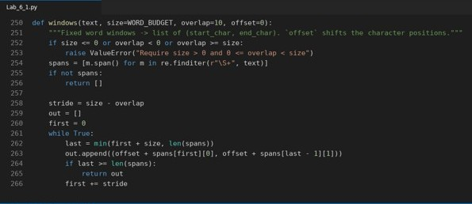
Figure 3. windows() in VS Code: fixed word windows with validation of size and overlap.
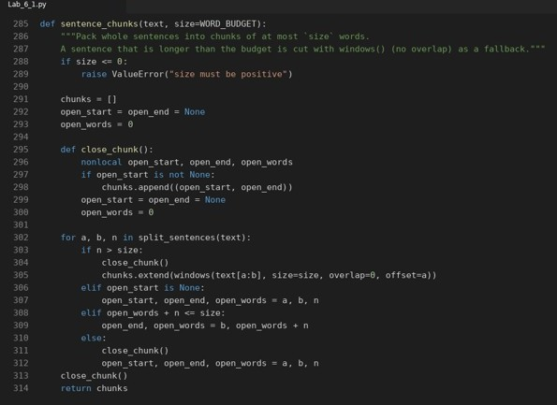
Figure 4. sentence_chunks() in VS Code: whole sentences packed up to the 40-word budget.
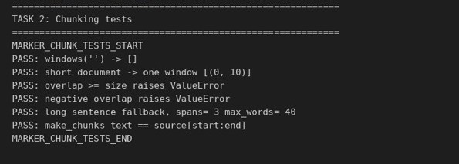
Figure 5. Terminal output of the chunking tests (all PASS).

4.1 Deliberately conflicting content
The synthetic documents contain related passages that disagree with each other. I added them to make failures from conflicting sources easy to see:
- The late document applies a penalty of 10 percent per day with a cap of three days. The assignment document mentions a five-day portal window with a flat five percent fee.
- The printer document sets the monthly quota at 150 pages, but also mentions an old door notice that still says 200 pages.

4.2 Chunk statistics
Table 4. Chunk statistics per strategy (all five documents, 1,038 words in total)
Strategy | Chunk count | Min words | Max words | Avg words | Duplicated words (chunk total - original)
0overlap | 28 | 15 | 40 | 37.07 | 0
10overlap | 35 | 16 | 40 | 38.23 | 300
sentence | 34 | 7 | 40 | 30.53 | 0

The total of 1,038 words is the sum of the five document word counts in Table 1 (218 + 196 + 226 + 183 + 215). It is consistent with the table: for example, 10overlap holds 1,038 + 300 = 1,338 words across its 35 chunks, and 28 × 37.07 is about 1,038.
Overlap buys safety at a price. The 10-word overlap adds 300 repeated words and seven more chunks than the zero-overlap version, so there is more text to index and more near-duplicate chunks that can compete for the top three places. Sentence packing duplicates nothing and gives 34 chunks, but its shortest chunk has only 7 words because a short sentence can be left on its own, which may leave too little context.
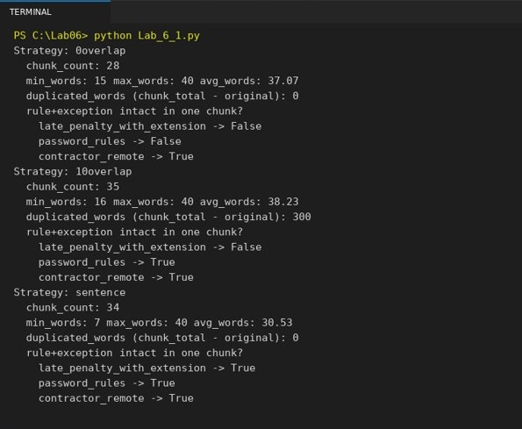
Figure 6. Terminal output of the chunk statistics and rule-plus-exception check per strategy.
Table 4b. Task 2 summary: the three chunking strategies side by side
Strategy | Chunk count | Avg words | Dup. words | Rules intact | Embedding Hit@3 dev / test
0overlap | 28 | 37.07 | 0 | 1 of 3 | 0.750 / 0.500
10overlap | 35 | 38.23 | 300 | 2 of 3 | 0.750 / 0.750
sentence | 34 | 30.53 | 0 | 3 of 3 | 1.000 / 1.000
Table 4b combines the chunk statistics (Table 4), the rule-plus-exception check (Table 5) and the embedding Hit@3 from Table 7, so the effect of each chunking choice can be read on one row.

4.3 Does a chunk keep a rule together with its exception?
A policy is only safe to quote if the rule and its condition travel together. The run tested three rule-plus-exception pairs and checked whether each one ended up whole inside a single chunk.
Table 5. Rule and exception intact in one chunk?
Check | 0overlap | 10overlap | sentence
late_penalty_with_extension | False | False | True
password_rules | False | True | True
contractor_remote | True | True | True

Only sentence-aware packing kept all three pairs intact. Fixed windows can slice through the middle of a rule: with no overlap, two of the three pairs were broken, and a 10-word overlap rescued only password_rules. The late-penalty pair needed sentence boundaries to stay whole. This result foreshadows the evaluation in Section 6, where evidence is only accepted if the complete string is present.

5. TF-IDF versus Embedding Retrieval
To see the difference between the two backends directly, I ran three paraphrased questions through both and looked at the top three chunks. Each entry shows the chunk ID (document:index), the cosine score and the character offsets in the source document.
These three queries were run on the sentence-based chunks (make_chunks(DOCS, "sentence")), the same chunking that was later selected.

Query A: “How can I regain access to my account?”
Table 6a. Top three chunks
Rank | TF-IDF | Embedding
1 | contractor:0 0.254 (0-263) | password:0 0.489 (0-253)
2 | contractor:5 0.150 (1084-1255) | password:4 0.468 (751-998)
3 | password:4 0.121 (751-998) | password:3 0.442 (531-750)

TF-IDF ranked the contractor document first and second, probably because the contractor text talks about accounts and access, and the real answer (the password document) only appears third. The embedding backend returned three password chunks, with the reset procedure at the top. The question has almost no words in common with “Forgot Password”, so this is a clear paraphrase win for embeddings.

Query B: “I was sick; can I hand work in tomorrow?”
Table 6b. Top three chunks
Rank | TF-IDF | Embedding
1 | late:1 0.236 (93-275) | late:1 0.226 (93-275)
2 | contractor:4 0.228 (895-1083) | late:6 0.225 (1132-1317)
3 | assignment:1 0.181 (224-484) | assignment:2 0.216 (485-545)

Both backends put the penalty rule (late:1) first. After that they diverge. TF-IDF’s second result is the contractor remote-work chunk, which is unrelated. The embedding model’s second result is late:6, a note about a conflicting portal notice mentioning a five-day window, so it stays in the right document but surfaces the conflict. Its score is only 0.001 below the first, and the third chunk is close behind at 0.216, so the scores give little guidance about which chunk to trust. That is an early sign that a confirmation step is needed.

Query C: “My printer has power but the pages come out blank.”
Table 6c. Top three chunks
Rank | TF-IDF | Embedding
1 | printer:5 0.292 (1081-1270) | printer:4 0.506 (868-1080)
2 | printer:4 0.234 (868-1080) | printer:1 0.439 (219-449)
3 | printer:0 0.166 (0-218) | printer:2 0.412 (450-655)

All six results come from the printer document, but the order differs. TF-IDF put printer:5 first, which is the passage about the old 200-page door notice, and the useful passage (printer:4, which advises checking ink levels and running the cleaning utility for blank pages) came second. The embedding backend ranked printer:4 first with a clear gap (0.506 against 0.439).
Overall, embeddings were better at matching meaning when the wording differed from the handbook, while TF-IDF could be drawn toward chunks that merely share common words.

6. Evaluation: Development and Held-Out Test

6.1 Protocol and metrics
There were four development queries (dev1 to dev4) and four answerable held-out test queries (test1 to test4). I compared strategies and backends on the development queries only and kept the test queries for a final check. The test split also contains two unanswerable queries (unans1 and unans2), which are logged and printed but skipped when Hit@3 and MRR@3 are computed.
A retrieved chunk counts as a hit only if it comes from the labeled document and contains the full evidence string, including its condition or exception. A chunk from the correct document that contains only half of the rule is therefore a miss. This strict rule is what makes chunk boundaries matter.
- Hit@3: the fraction of queries for which at least one hit appears among the top three chunks.
- MRR@3: the mean over queries of 1/rank of the first hit within the top three, counting 0 if there is no hit.
The queries were split as follows:
- Development: dev1 “What is the late penalty and when is late work refused?” (late); dev2 “How do I reset my university password?” (password); dev3 “What file formats are accepted for assignment upload?” (assignment); dev4 “Can contractors work remotely?” (contractor).
- Held-out test: test1 “What proof is needed when I was ill and need more time?” (late); test2 “What are the rules for a new password?” (password); test3 “How many pages is the monthly student print quota?” (printer); test4 “What should I do for blank printer pages?” (printer).
- Unanswerable (not scored): unans1 “What are tomorrow’s flight prices?” and unans2 “Who won the football match?”, both with no matching document.
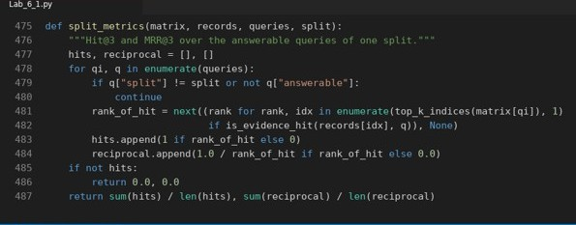
Figure 7. split_metrics() in VS Code: Hit@3 and MRR@3 over the answerable queries of one split.

6.2 Results
Table 7. Hit@3, MRR@3, chunk count and timing for every configuration
Strategy | Backend | Dev Hit@3 | Dev MRR@3 | Test Hit@3 | Test MRR@3 | Chunks | Encode (s) | Search (s)
0overlap | tfidf | 0.750 | 0.750 | 0.250 | 0.250 | 28 | 0.004 | 0.000
0overlap | embedding | 0.750 | 0.750 | 0.500 | 0.500 | 28 | 0.167 | 0.000
10overlap | tfidf | 0.750 | 0.750 | 0.500 | 0.500 | 35 | 0.004 | 0.000
10overlap | embedding | 0.750 | 0.750 | 0.750 | 0.625 | 35 | 0.215 | 0.000
sentence | tfidf | 1.000 | 1.000 | 0.500 | 0.500 | 34 | 0.004 | 0.000
sentence | embedding | 1.000 | 1.000 | 1.000 | 0.875 | 34 | 0.219 | 0.000

The original run reported dev and test as separate rows. Here they are placed side by side; the chunk count, encoding time and search time are identical for both splits of a configuration. The shaded row is the configuration that was selected (Section 7).

6.3 Interpretation
- Chunking mattered most on the development set. Both sentence-based configurations reached 1.000 for Hit@3 and MRR@3, while all four window-based configurations stayed at 0.750.
- The backends were tied on development data but separated on test data. With the same chunker, TF-IDF and embeddings scored identically in development. On the held-out queries, embeddings were ahead in every strategy: 0.500 vs 0.250 (0overlap), 0.750 vs 0.500 (10overlap) and 1.000 vs 0.500 (sentence) for Hit@3.
- Overlap helped but did not close the gap. For embeddings, test Hit@3 rose from 0.500 (no overlap) to 0.750 (10-word overlap) and then to 1.000 with sentence packing.
- Embedding cost is small here. Encoding took 0.167 to 0.219 seconds for embeddings against 0.004 seconds for TF-IDF, and search time rounds to 0.000 seconds in every row because the collection is tiny.
- The sample is small. With only four queries per split, each query is worth 0.25 of Hit@3, so one query can change a result a lot. The numbers show a pattern, not a precise ranking.

7. Selecting the Final Configuration
The selection used development results only. The rule was to choose the highest development Hit@3, break ties with development MRR@3, and, if there was still a tie, prefer the embedding backend because the chatbot needs to cope with paraphrased questions.
Two configurations tied at the top of the development table: sentence + tfidf and sentence + embedding, each with Hit@3 = 1.000 and MRR@3 = 1.000. The tie-break therefore chose embeddings, giving sentence + embedding. Only after that was the held-out test set read, and the choice was left unchanged.
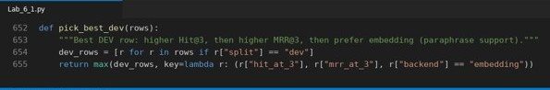
Figure 8. pick_best_dev() in VS Code: selection uses development rows only.
Table 8. Selected configuration
Selected from development only | Hit@3 | MRR@3
Development (sentence + embedding) | 1.000 | 1.000
Held-out test (same configuration) | 1.000 | 0.875

The test Hit@3 of 1.000 shows that the right evidence appeared in the top three for all four test queries. The MRR@3 of 0.875 means that it was not always ranked first. With four queries, this value works out only if three queries had the evidence at rank 1 and one had it at rank 2 (an inference from the arithmetic, since individual ranks are not printed).

8. Chatbot Transcripts and Fallback Behavior
I built two terminal chatbots on top of the retrieval code. Their shared design goal is that they should not state a policy as fact unless the user has seen and chosen the evidence.

8.1 FAQ bot (TF-IDF)
The FAQ bot matches the user’s text against a small list of stored questions using TF-IDF. Its behaviour has three cases:
- If the input is exactly a stored (canonical) question, it returns the saved answer together with a source file name.
- If the input is anything else, it only offers a ranked list of possible matches with similarity scores. The user still has to ask the canonical question to get an answer.
- If the input is empty, or nothing in the FAQ matches, it falls back with a short message instead of guessing.
Transcript 1. FAQ bot session from the run
You: How do I reset my password?
Bot: Use the recovery link on the login page. [source: it_help.txt]

You: password recovery
Bot: Possible matches; choose or rephrase your question:
How do I reset my password? (similarity 0.407)
How do I connect to campus Wi-Fi? (similarity 0.124)
Where do I submit my assignment? (similarity 0.000)

You: ''
Bot: Please enter a question.

You: volcano geology
Bot: No matching FAQ. Please contact the help desk.

You: What is the monthly student print quota?
Bot: Students get 150 black and white pages each month. [source: printer_policy.txt]

You: How do I connect to campus Wi-Fi?
Bot: Join Eduroam and sign in with your university email and password. [source:
network_guide.txt]

The session shows each branch. The canonical questions about passwords, printing and Wi-Fi return an answer with its source. “password recovery” is not a stored question, so the bot offers suggestions and ranks the password question first at 0.407, while the other two are far lower. The empty input and the unrelated phrase “volcano geology” both trigger a fallback message.
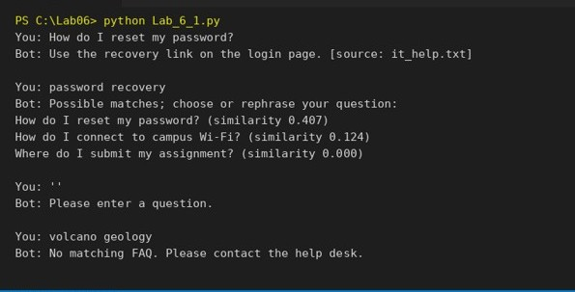
Figure 9. Terminal output of the FAQ chatbot demo.

8.2 Document bot (confirmation-based)
The document bot searches the handbook chunks with the selected configuration. It does not answer straight away. Instead it follows a short confirmation flow:
- It lists the top three candidate chunks with the chunk ID, a score and the character offsets in the source document, plus a truncated preview.
- The user reads the candidates and chooses 1, 2 or 3 to see the full passage.
- If the user presses Enter or types an invalid choice, no answer is selected and the bot suggests rephrasing or contacting a person.
Because nothing is shown as an answer until the user picks it, unanswerable questions are never asserted as answers. The label “Candidate evidence; relevance must be checked” appears whenever candidates are shown.
In the scripted demos the choices are fixed in the code (demo_document_chatbot): the first two cases choose candidate 1, while the empty and unsupported cases choose nothing. In the interactive chatbot (run_chatbot) the user types the number themselves.
Transcript 2. Demo: a question with a rule and an exception
Question: What is the late penalty and when is late work refused?
Candidate evidence; relevance must be checked:
1 late:1 0.844 characters 93 275
Late work receives a 10 percent penalty for each calendar day late, up to three
days, and is refused after that unless a...
2 late:3 0.645 characters 471 639
Late penalties are applied automatically by the grading system and appear on the
feedback sheet. Group projects follow t...
3 assignment:6 0.531 characters 1177 1414
Important conflict note: the portal help page states late uploads are accepted for
up to five calendar days with a flat ...

Retrieved passage: Late work receives a 10 percent penalty for each calendar day
late, up to three days, and is refused after that unless a formal extension was
approved in writing before the deadline.
Source: late characters 93 275

Candidate 1 contains the complete rule and its exception, and it is the highest-scoring result by a clear margin. Candidate 3 is more important than its score suggests: it comes from the assignment document and states a different late policy. A confirmation step lets the user notice that two documents disagree, which a bare answer would hide.
Transcript 3. Demo: paraphrased question
Question: How can I recover my login access?
Candidate evidence; relevance must be checked:
password:0 0.530 characters 0 253
Password reset procedures for university accounts are handled through the IT
self-service portal. Navigate to the login
password:4 0.427 characters 751 998
Shared passwords between classmates violate the acceptable use policy and may lead
to account suspension. Contact helpdesk
password:3 0.397 characters 531 750
If you do not receive the email, check the spam folder first. Staff at the IT help
desk can reset passwords in person af...

Retrieved passage: Password reset procedures for university accounts are handled
through the IT self-service portal. Navigate to the login page and select Forgot
Password, then enter your student email and complete an identity check with your
student ID and date of birth.
Source: password characters 0 253

The wording “recover my login access” does not repeat the handbook’s “password reset” wording, yet all three candidates come from the password document and the reset procedure is first at 0.530. This is the paraphrase support that motivated choosing embeddings.
Transcript 4. Demo: empty input
Question: '
No candidate evidence; rephrase or contact a human.

Transcript 5. Demo: unsupported question
Question: What are tomorrow's flight prices?
Candidate evidence; relevance must be checked:
1 assignment:2 0.200 characters 485 545
window and support tickets already fill the help desk queue.
2 late:6 0.146 characters 1132 1317
Please note a conflicting portal notice elsewhere may mention a five day window, but
this late policy document is the as.
3 printer:0 0.094 characters 0 218
Campus printer and print quota rules are managed by IT services for students and
visitors. Each student receives a month...

No answer selected. Rephrase or contact a human.

Empty input produces no candidates at all. The flight-price question is a different matter: the handbook says nothing about flights, but the system still returns the three nearest chunks, with low scores of 0.200, 0.146 and 0.094. None of them is relevant, and because no candidate is chosen, the bot ends with a request to rephrase or contact a person. The confirmation step is what turns these meaningless neighbours into a safe outcome.

9. Limitations and Failure Cases
This section only discusses failures that appeared in the output printed by the script (the run output file run_output.txt), plus design limits that follow directly from the supplied results.

9.1 Automatic failure list
The script records every answerable query for which the top three chunks did not contain a hit under the strict evidence rule, across all six configurations and both splits, but it prints only the first eight entries (failures[:8]). In each printed entry the chunk shown is the top-ranked one (its rank field is always 1), and it comes from the expected document but does not hold the full evidence string.
Table 9. Failures printed by the script
# | Config | Query | Expected doc | Retrieved chunk (rank 1)
1 | 0overlap tfidf | What is the late penalty and when is late work refused? | late | late:0
2 | 0overlap tfidf | What proof is needed when I was ill and need more time? | late | late:0
3 | 0overlap tfidf | What are the rules for a new password? | password | password:0
4 | 0overlap tfidf | What should I do for blank printer pages? | printer | printer:2
5 | 0overlap embedding | What is the late penalty and when is late work refused? | late | late:0
6 | 0overlap embedding | What are the rules for a new password? | password | password:2
7 | 0overlap embedding | What should I do for blank printer pages? | printer | printer:1
8 | 10overlap tfidf | What is the late penalty and when is late work refused? | late | late:0

The failures cluster in the fixed-window strategies, which fits the chunk-integrity results in Table 5. No sentence-strategy entry appears in the printed list only because of the eight-entry cap: the list is filled in configuration order (0overlap tfidf, 0overlap embedding, then 10overlap tfidf) before the sentence configurations are reached. Counting from Table 7, the full set of failing queries is 4 for 0overlap tfidf, 3 for 0overlap embedding, 3 for 10overlap tfidf, 2 for 10overlap embedding, 2 for sentence tfidf and none for sentence embedding, 14 in total. For example, sentence tfidf misses test1 (top chunk late:1) and test2 (top chunk password:0).

9.2 Selected failure cases

Failure case 1
Query | What is the late penalty and when is late work refused?
Config / expected | 0overlap tfidf | expected document: late
Retrieved | late:0: “University late submission policy applies to all undergraduate coursework in taught modules. Late work receives a 10 percent penalty for each calendar day late, up to three days, a...”

The chunk comes from the right document but holds only the start of the rule. With no overlap, the rule occupies characters 93 to 275 of the late document, and the window boundary falls at character 247: late:0 covers characters 0 to 246 and late:1 covers 247 to 518. The part about refusal after three days and approved extensions therefore sits in the next chunk, and no single chunk contains the full evidence string. The embedding backend fails on this query for the same reason (entry 5), so this is a chunk-boundary failure rather than a ranking failure. Sentence-aware packing fixes it, and the confirmation step lets the user see that a passage is incomplete.

Failure case 2
Query | What proof is needed when I was ill and need more time?
Config / expected | 0overlap tfidf | expected document: late
Retrieved | late:0 (the same introductory chunk as in failure case 1)

Chunking was not the cause here. With no overlap, the labeled evidence about the medical certificate (characters 276 to 470) lies entirely inside late:1. TF-IDF still ranked late:0 first and did not place late:1 in its top three, most likely because the question (“proof”, “ill”, “more time”) shares few exact words with the handbook sentence (“medical certificate”, “extensions”). This is a ranking failure, and the 0overlap embedding configuration does not fail on this query, which is the kind of wording gap that embeddings are better at bridging.

Failure case 3
Query | What are the rules for a new password?
Config / expected | 0overlap tfidf | expected document: password
Retrieved | password:0: “Password reset procedures for university accounts are handled through the IT self-service portal. Navigate to the login page and select Forgot Password, then enter your student ema...”

The top chunk is the reset procedure, not the password rules. The labeled evidence for the rules is characters 365 to 530 of the password document, and with no overlap it straddles the boundary between password:1 (254 to 475) and password:2 (476 to 710), so no chunk can count as a hit for either backend (entries 3 and 6). A 10-word overlap produces a chunk that starts at character 365 and holds the rule whole, and sentence packing also keeps it whole, although TF-IDF still ranks the reset chunk first under 10overlap. Chunk integrity and ranking quality are two separate problems that both have to be right.
This example also exposes a limit of the sentence splitter. It splits at a period followed by a space, so abbreviations such as “Mr.” or “e.g.” would wrongly end a sentence. It is a simple splitter written for teaching, and I treat that as a known limitation.

9.3 FAQ matching versus document retrieval
 | FAQ bot | Document bot
Strength | Safe and predictable. An exact stored question returns a short answer and a source file name. | Surfaces the actual handbook text with offsets, which is better when an answer depends on a condition or exception.
Weakness | Paraphrases only give suggestions, and a short stored answer leaves little room for context from a long policy. | Documents can contradict each other, and a high score does not say which policy wins.
Mitigation | Ask the user to rephrase or contact the help desk. | Show several candidates and let the user confirm a passage rather than stating it as fact.

The conflict between the late and assignment documents is a good illustration. Both are retrieved for late-work questions, and the similarity score alone cannot tell which one is the authoritative policy. That is why the document bot never presents a passage as the final answer without user confirmation.

9.4 Other limitations
- Nearest neighbours always exist. Cosine similarity ranks chunks even for questions the handbook cannot answer, as the flight-price demo shows. No score threshold was calibrated to reject such queries, so the fallback relies on the user rejecting the candidates.
- Small evaluation set. There are only four development queries and four test queries, so the results are indicative rather than conclusive.
- Synthetic data. The documents are short and written for the exercise. Real handbooks are longer, messier and may include tables or version history.
- Very short chunks. Sentence packing produced a chunk with only 7 words, which may carry too little context.
- Unanswerable queries are not scored. The two unanswerable test queries are excluded from Hit@3 and MRR@3 (answerable = False), so the metrics say nothing about how well the system rejects questions it cannot answer.

10. Reflection

What did you learn today?
I learned that the choice of tokenizer is not a minor detail. Whitespace splitting, the regex and the model’s subwords all cut the same short sentence differently, and those differences decide what a search can match. I also saw that a retriever can find the right passage and still fail the task if the chunk boundary hides an exception. That is why Hit@3 had to require both the correct document and the full evidence text.

How will you apply this in a real AI system?
I would store a source ID and character offsets for every chunk so any answer can be traced to its place in the original document. I would tune the system on development queries and report results on a separate held-out set. I would also ask the user, or a human reviewer, to confirm a passage before it is shown as policy. Finally, I would time model loading separately from encoding and search so the reported speed is honest.

What failed or surprised you?
What surprised me most was how misleading a score can be. When documents conflicted, or when TF-IDF missed a paraphrase, a fairly high score still pointed to the wrong place. The failure list printed by the script made this impossible to ignore. I was also struck that cosine similarity returns neighbours even for a flight-price question, so a system like this needs a proper fallback for questions it cannot answer.

What would you do differently next time?
I would make the sentence splitter aware of abbreviations, and add metadata such as the intended audience or policy version to each chunk so conflicts can be resolved sooner. I would also set a rejection threshold using separate development examples rather than relying on raw top-1 scores.

11. Steps to Reproduce
Run these commands from the folder that contains Lab_6_1.py (the commands use the Windows virtual-environment path):
- Create a virtual environment: python -m venv .venv
- Activate it: .venv\Scripts\activate
- Install the dependencies: pip install numpy scikit-learn sentence-transformers
- Run the lab script, which produces the tokenization, chunking, retrieval, evaluation and chatbot output: python Lab_6_1.py

